

**Inclusion Policy**

**Provisions and Practices at St Leonards:**

The purpose of this policy is to ensure that the commitment expressed below in practice and that St Leonards meets all applicable statutory requirements.

In accordance with its Accessibility Strategy, Equal Opportunities and Child Protection Policies, St Leonards aims to ensure that the school is, within the framework of the Admissions Policy, an educationally inclusive IB World School and that the teaching and learning, achievements, attitudes and well-being of every pupil, matter. St Leonards aims to provide an inclusive IB curriculum designed to meet the needs of the pupils accepted into the school, including those with disabilities and/or additional support needs (ASN), students from all cultural backgrounds and students for whom English is an additional language.

All students may have special needs at different times and a wide variety of strategies are used to make reasonable adjustments and meet these needs as they arise. Barriers to learning and participation are challenged to help provide all pupils with equality of opportunity. The school aims to provide access to a broad, balanced, relevant and differentiated curriculum, as well as access to all other relevant aspects of school life. Parents have the responsibility to disclose at the time of application to St Leonards any condition/circumstances which are likely to cause their child to require additional support and should forward relevant documents such as assessments by educational psychologists or existing ISPs (Individual Support Plans) to the school. This information will be then circulated to relevant departments to support the pupil.

**Beliefs**

Our commitment is based on the following principles:

1. Pupils have equal rights to an appropriate and rounded education.
2. Pupils are special, different and have individual needs.
3. Pupils are equally valued and have a right to voice their views.
4. Pupils are entitled to a broad, balanced and relevant curriculum.
5. Pupils are encouraged to reach their full potential by building on strengths and using suitable strategies to minimise barriers to learning.
6. Where applicable, pupils receive relevant special provision in examinations.
7. All staff, teaching and non-teaching, have regard to the needs of individuals within the schools.
8. Parents are valued as genuine partners.
9. The view of the individual pupil is valued and taken into account wherever possible/practicable.

**The Support for Learning Department**

At St Leonards, each pupil referred to the Support for Learning Department or identified as “at risk” through screening, is considered individually, and a number of flexible methods are used to identify and support his or her needs. If a pupil is deemed to have ASN requiring extra support, group lessons for all ages are provided as part of the termly fee. If a parent or guardian requests additional support beyond this or opts for additional individual lessons, these would normally be charged in addition to the termly school fees in the MYP and DP/CP programmes but not in the PYP.

Across all programmes, pupils with ASN are allocated a fixed lesson in a study period where possible. If no suitable study period exists, pupils come out of class on a rota basis so that their progress in other subjects is not disrupted. Sessions are normally the same length as the school periods, 40 -45 minutes, but in the Junior School there may be several shorter sessions instead e.g. individual reading.

It is the policy of the Support for Learning Department to carry out an initial learning assessment of pupils entering Year 7, whether from St Leonards Junior School or an outside school. The results of these computerized tests provide a baseline assessment to be referred back to in the case of future need. Should these tests indicate a need for Learning Support lessons, parents will be informed and permission requested. Parents may view these results and those of any other LS assessments by request.

As a department, the Support for Learning Team:

1. - Assesses and reviews literacy and numeracy skills of individual pupils and prepares inclusive access arrangements applications for the IBO for DP and CP candidates.
2. - Provides advice,support and regular professional workshops for members of staff throughout the school, helping teachers to identify and make provision, through normal classroom differentiation and support, for children with ASN from Years 1 to 13.
3. - Liaises with parents as requested.

-Liaises with the Wellbeing Hub Team regarding pupils’ needs.

1. - Recommends resources for teaching and assessment in consultation with the department heads.
2. - Provides appropriate support for learning for their pupils, including the regular preparation of individual reports.
3. - Plans and implements intervention strategies following the advice of outside agencies or the results of internal assessments.
4. - Formulates and reviews a Learning Support Report for those pupils receiving LS.
5. - Liaises as required with medical staff and Year-Heads over mental health issues such as anxiety.
6. - Liaises with the Head of EAL and English B around access arrangements for pupils with English as a second language.
7. - Regularly addresses the teaching staff during the INSET Day immediately prior to the beginning of each Autumn Term concerning current and new pupils to the Senior School, whether from the Junior School or outside, to allow the teachers to be prepared for differing specific needs right from the start of the term.

**The Role of Heads of Department and Classroom Teachers**

Within individual subject departments, the Heads of Department and subject specialists arrange the provision of schemes of work and unit plans and associated resources appropriate to a range of aptitude, ability and learning styles for the class teachers to use. The class teacher, with the support of the Learning Support Department, addresses the differing needs of pupils in the classroom itself and in the homework set. Class and subject teachers have an important role to play both in identifying a cause for concern and in facilitating learning in the classroom.

**The Role of Heads of Year and Programme Coordinators**

The Heads of Year and the programme coordinators will work with pupils who require extra support because of behavioural, emotional or social needs. Such pupils are referred to the appropriate section head who will liaise with medical staff, parents and external agencies as required. Weekly meetings take place where pupils of particular concern are raised and strategies established using GIRFEC and SHANARRI criteria. (The Children and Young people (Scotland) Act 2014).

**Admissions Arrangements**

All pupils applying to enter the Senior School are required to complete the Cat 4 assessments in English, Mathematics and Logic. Pupils for whom English is not a first language will also sit the Password test to assess their proficiency in English. Where a child has a specific learning difficulty, previous psychological assessments, ISPs and school reports will be studied carefully in conjunction with the entrance tests. Where appropriate, further assessment will be carried out to ensure that such prospective pupils are not disadvantaged by a disability, provided the criteria for admission are sustained. Full disclosure is essential at admission. The Head of Learning Support liaises closely with parents of children with ASN to establish the provision needed for entrance and the child’s normal way of working.

**Arrangements for the Consideration of Complaints**

Should parents have cause for complaint about any aspect of inclusion, they are invited to make representation to the Head. The school will follow the complaints procedure as set out in its Complaints Policy.

**EU General Data Protection Regulation (2018) GDPR**

In accordance with the GDPR pupil records will be held in secure locations to maintain pupil confidentiality. The data will be permanently deleted in line with the school’s deletion policy when no longer required by the pupil.

**Education Scotland requirements**

This policy statement has been drawn up in cognisance of the provisions of the Education (Additional Support for Learning) (Scotland) Act 2004 and 2009, the SCIS Handbook on Accessibility 2nd edition June 2006, the Education (Additional Support for Learning (Scotland) Act 2010 Code of Practice, and the Equality Act 2010 (including extensions of reasonable adjustments in force from 1st September 2012), together with the Guidance for Reasonable adjustments for disabled pupils Scotland from the Equality and Human Rights Commission 2014.

**Identification of Support Required**

The School follows the IB Decision Pathway (pictured below) when considering inclusive access arrangements for pupils. Progress through the flowchart is accompanied by dedicated pastoral support from tutors and Heads of Year in collaboration with programme coordinators. There is regular dialogue with the IB Inclusion Team surrounding queries or concerns.

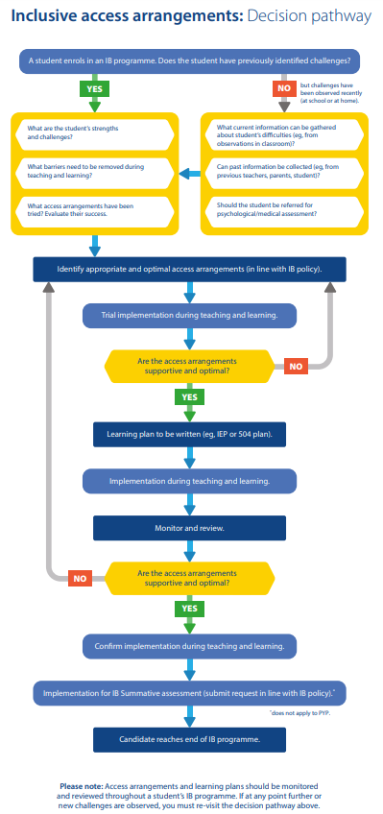

IBO (2019) *Inclusive Access Arrangements.* Available at <https://blogs.ibo.org/files/2019/09/decisionpathway-english-final.pdf> (Accessed: 27 March 2023)

Created 2016

Updated March 2023

To be reviewed March 2025